

**K. J. Somaiya College of Engineering, Mumbai-77 (A constituent college of Somaiya Vidyavihar University)**

**Batch: A2 Roll No.: 16010121028**

**Experiment No: 02**

**Group No: 5**

**DIGIPOLLS**

| **Title: Design Document for MiniProject.** |
| --- |

**______________________________________________________________________ Objective: Understand the necessity of design document.**

**______________________________________________________________________ Expected Outcome of Experiment:**

Understand the necessity of design document.

**_________________________________________________________________ Books/ Journals/ Websites referred:**

https://www.researchgate.net/figure/Blockchain-based-e-voting-system

architecture_fig2_357827345

https://www.investopedia.com/terms/b/blockchain.asp

https://core.ac.uk/download/pdf/155779036.pdf

**______________________________________________________________**

**Introduction:**

As the process of development of a project progresses, the second important stage is the design.

**DIGIPOLLS**

**An e voting system using blockchain technology.**

Department of Computer Engineering (Mini Project) Page 1



**K. J. Somaiya College of Engineering, Mumbai-77**

**(Autonomous College Affiliated to University of Mumbai)**

**Interface**

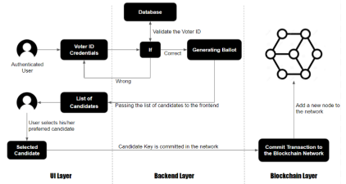

**Backend/ database design /Data design**

**SCHEMA**

Department of Computer Engineering (Mini Project) Page 2



**K. J. Somaiya College of Engineering, Mumbai-77**

**(Autonomous College Affiliated to University of Mumbai)** 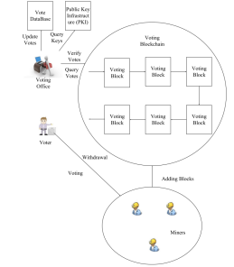

**VOTING BLOCK SCHEMA**

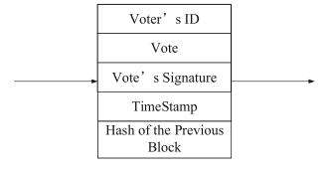**INITIALIZATION OF VOTING SYSTEM**

Department of Computer Engineering (Mini Project) Page 3



**K. J. Somaiya College of Engineering, Mumbai-77**

**(Autonomous College Affiliated to University of Mumbai)** 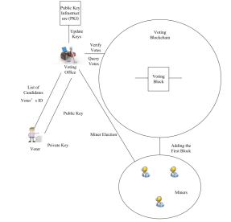

**VOTING**

Department of Computer Engineering (Mini Project) Page 4



**K. J. Somaiya College of Engineering, Mumbai-77**

**(Autonomous College Affiliated to University of Mumbai)** 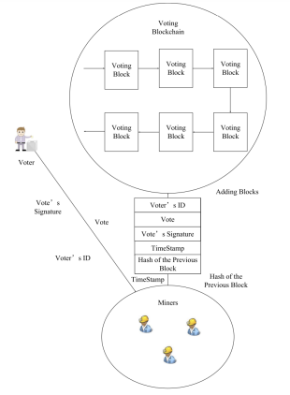

**Architectural design**

Department of Computer Engineering (Mini Project) Page 5



**K. J. Somaiya College of Engineering, Mumbai-77**

**(Autonomous College Affiliated to University of Mumbai)** 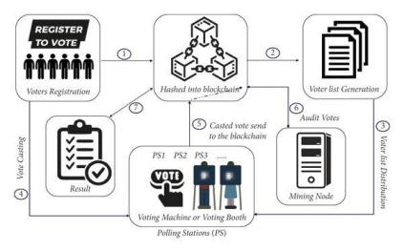

Above is reference from https://www.researchgate.net/figure/Blockchain based-e-voting-system-architecture_fig2_357827345

SYSTEM ARCHITECTURE FOR VOTING

Department of Computer Engineering (Mini Project) Page 6



**K. J. Somaiya College of Engineering, Mumbai-77**

**(Autonomous College Affiliated to University of Mumbai)** 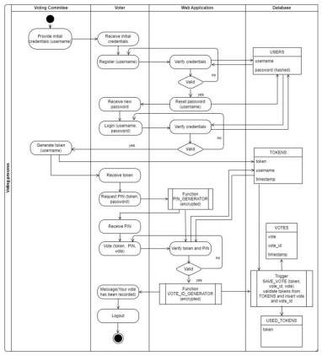

SYSTEM ARCHITECTURE FOR VALIDATION

Department of Computer Engineering (Mini Project) Page 7



**K. J. Somaiya College of Engineering, Mumbai-77**

**(Autonomous College Affiliated to University of Mumbai) **

WORK FLOW

**UML diagrams**

a. Use-case diagram:

Department of Computer Engineering (Mini Project) Page 8



**K. J. Somaiya College of Engineering, Mumbai-77**

**(Autonomous College Affiliated to University of Mumbai)**



b. Sequence Diagram: Authentication

c. Sequence Diagram: voting

Department of Computer Engineering (Mini Project) Page 9



**K. J. Somaiya College of Engineering, Mumbai-77**

**(Autonomous College Affiliated to University of Mumbai) **

d. Sequence Diagram: Validation

**Design of test cases.**

Department of Computer Engineering (Mini Project) Page 10



**K. J. Somaiya College of Engineering, Mumbai-77**

**(Autonomous College Affiliated to University of Mumbai) **

**Algorithmic design** FOR VOTING

Department of Computer Engineering (Mini Project) Page 11



**K. J. Somaiya College of Engineering, Mumbai-77**

**(Autonomous College Affiliated to University of Mumbai) **

FOR VALIDATION

Department of Computer Engineering (Mini Project) Page 12



**K. J. Somaiya College of Engineering, Mumbai-77**

**(Autonomous College Affiliated to University of Mumbai) **

**Snapshots of design:**

Department of Computer Engineering (Mini Project) Page 13



**K. J. Somaiya College of Engineering, Mumbai-77**

**(Autonomous College Affiliated to University of Mumbai) **

Department of Computer Engineering (Mini Project) Page 14



**K. J. Somaiya College of Engineering, Mumbai-77**

**(Autonomous College Affiliated to University of Mumbai) **

Department of Computer Engineering (Mini Project) Page 15



**K. J. Somaiya College of Engineering, Mumbai-77**

**(Autonomous College Affiliated to University of Mumbai) **

Department of Computer Engineering (Mini Project) Page 16



**K. J. Somaiya College of Engineering, Mumbai-77**

**(Autonomous College Affiliated to University of Mumbai) **

Department of Computer Engineering (Mini Project) Page 17



**K. J. Somaiya College of Engineering, Mumbai-77**

**(Autonomous College Affiliated to University of Mumbai) **

**Conclusion:**

The design presented here is well-suited for our e-voting system using blockchain in company elections. It ensures a smooth user experience, secure data handling, fault tolerance, and reliability. The inclusion of frontend interface, backend/database design, architectural design, UML diagrams, test case design, and algorithmic considerations guarantees the system's effectiveness, security, and usability. With thorough testing and emphasis on efficiency and security in algorithmic design, we're confident in the system's ability to facilitate transparent and trustworthy company elections.

Department of Computer Engineering (Mini Project) Page 18